**Convert value to primitive data type**

Although functions & operators automatically convert the values given to them to a suitable value that they can deal with, conversion process can be done manually by 2 ways.

There are two ways to convert data from any type to **primitive type**:

1. Using the **constructor**.
2. Using **methods**.

**First Using constructor**

We can convert data type from one type to **primitive type** by using the **constructor** of the type that we want to convert to it.

**Where** the constructor of string type is **String(value),** of number is **Number(value),** of boolean is **Boolean(value);** Without using new keyword.

Important notes:

|  |  |  |  |
| --- | --- | --- | --- |
| **value** | **String** | **Number** | **Boolean** |
| **0** | **“0”** | **0** | **false** |
| **“0”** | **“0”** | **0** | **true** |
| **“ “ whitespaces** | **“ ”** | **0** | **true** |
| **“” (empty string)** | **“”** | **0** | **false** |
| **“number”** | **“number”** | **number** | **true** |
| **“text”** | **“text”** | **NaN** | **true** |
| **true** | **“true”** | **1** | **true** |
| **false** | **“false”** | **0** | **false** |
| **null** | **nul** | **0** | **false** |
| **Undefined** | **‘Undefined’** | **NaN** | **false** |
| **NaN** | **‘NaN’** | **NaN** | **false** |
| **[]** | **Empty “”** | **NaN** | **true** |
| **[number]** | **“number”** | **number** | **true** |
| **[number1, number2]** | **“number1, number2”** | **number1** | **true** |
| **[“text”, “text”] or [“text”]** | **“text, text”** | **NaN** | **true** |
| **{} or {keys:values}** | **“object Object”** | **NaN** | **true** |

**Note:**

1. Any input by the user consider a string data type, so it’s important to convert it suitable data type.
2. Whitespaces from the beginning and ending of the string are removed when it converts to number. **“ 231 ” 🡺 231**

**Examples:** on converting different types to **number** type.

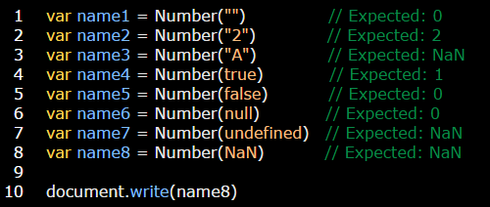

**Examples:** on converting different types to **string** type.

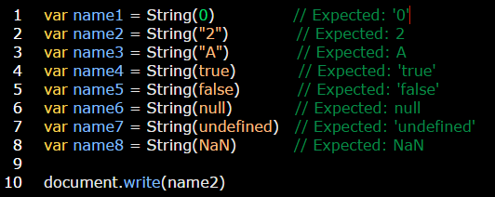

**Examples:** on converting different types to **Boolean** type.

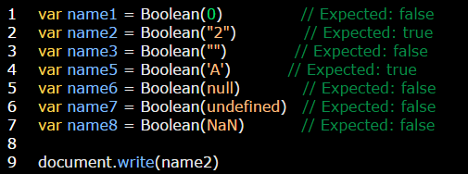

**Examples:** on converting **object** data types to **primitive** type.

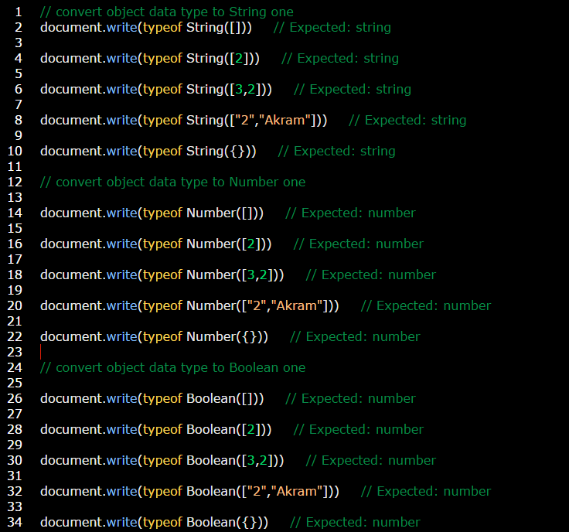

**Examples:**

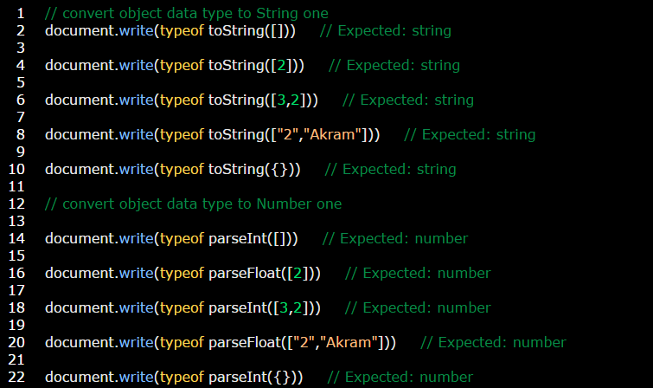

**Second Using methods**

There are another ways to convert any data type **(object | primitive)** to **string & number primitive type** by using **methods**:

* **toString()** method is used to convert any data type to **string** one.
* **parseInt()** method is used to convert any data type to **integer number**.
* **parseFloat()** method is used to convert any data type to **float number**.

**And you will get the same result in the above table.**

**Example:** on toString method:

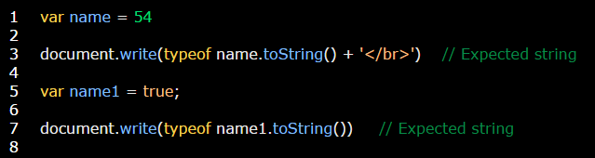

**Example:** on parseInt & parseFloat methods:

